

Product Design

and Operation

Project Design Document

GitHub: project-design-2019

Group 5 2019 05 07

# Project Design Document

## Introduction

Psychological counselling is becoming more and more popular with fast developing of China, psychological illness and mental disease is hitting not only adult but also the kids. According to the World Health Organization, the morbidity is over 17% for kids, some efficient approach must be adopted to help those kids for metal disease preventing and treatment. The disease include depression, infantile autism, hyperactivity, transient tic disorder, obsessive-compulsive disorder, schizophrenia, etc.

## General Design

### Project Architecture

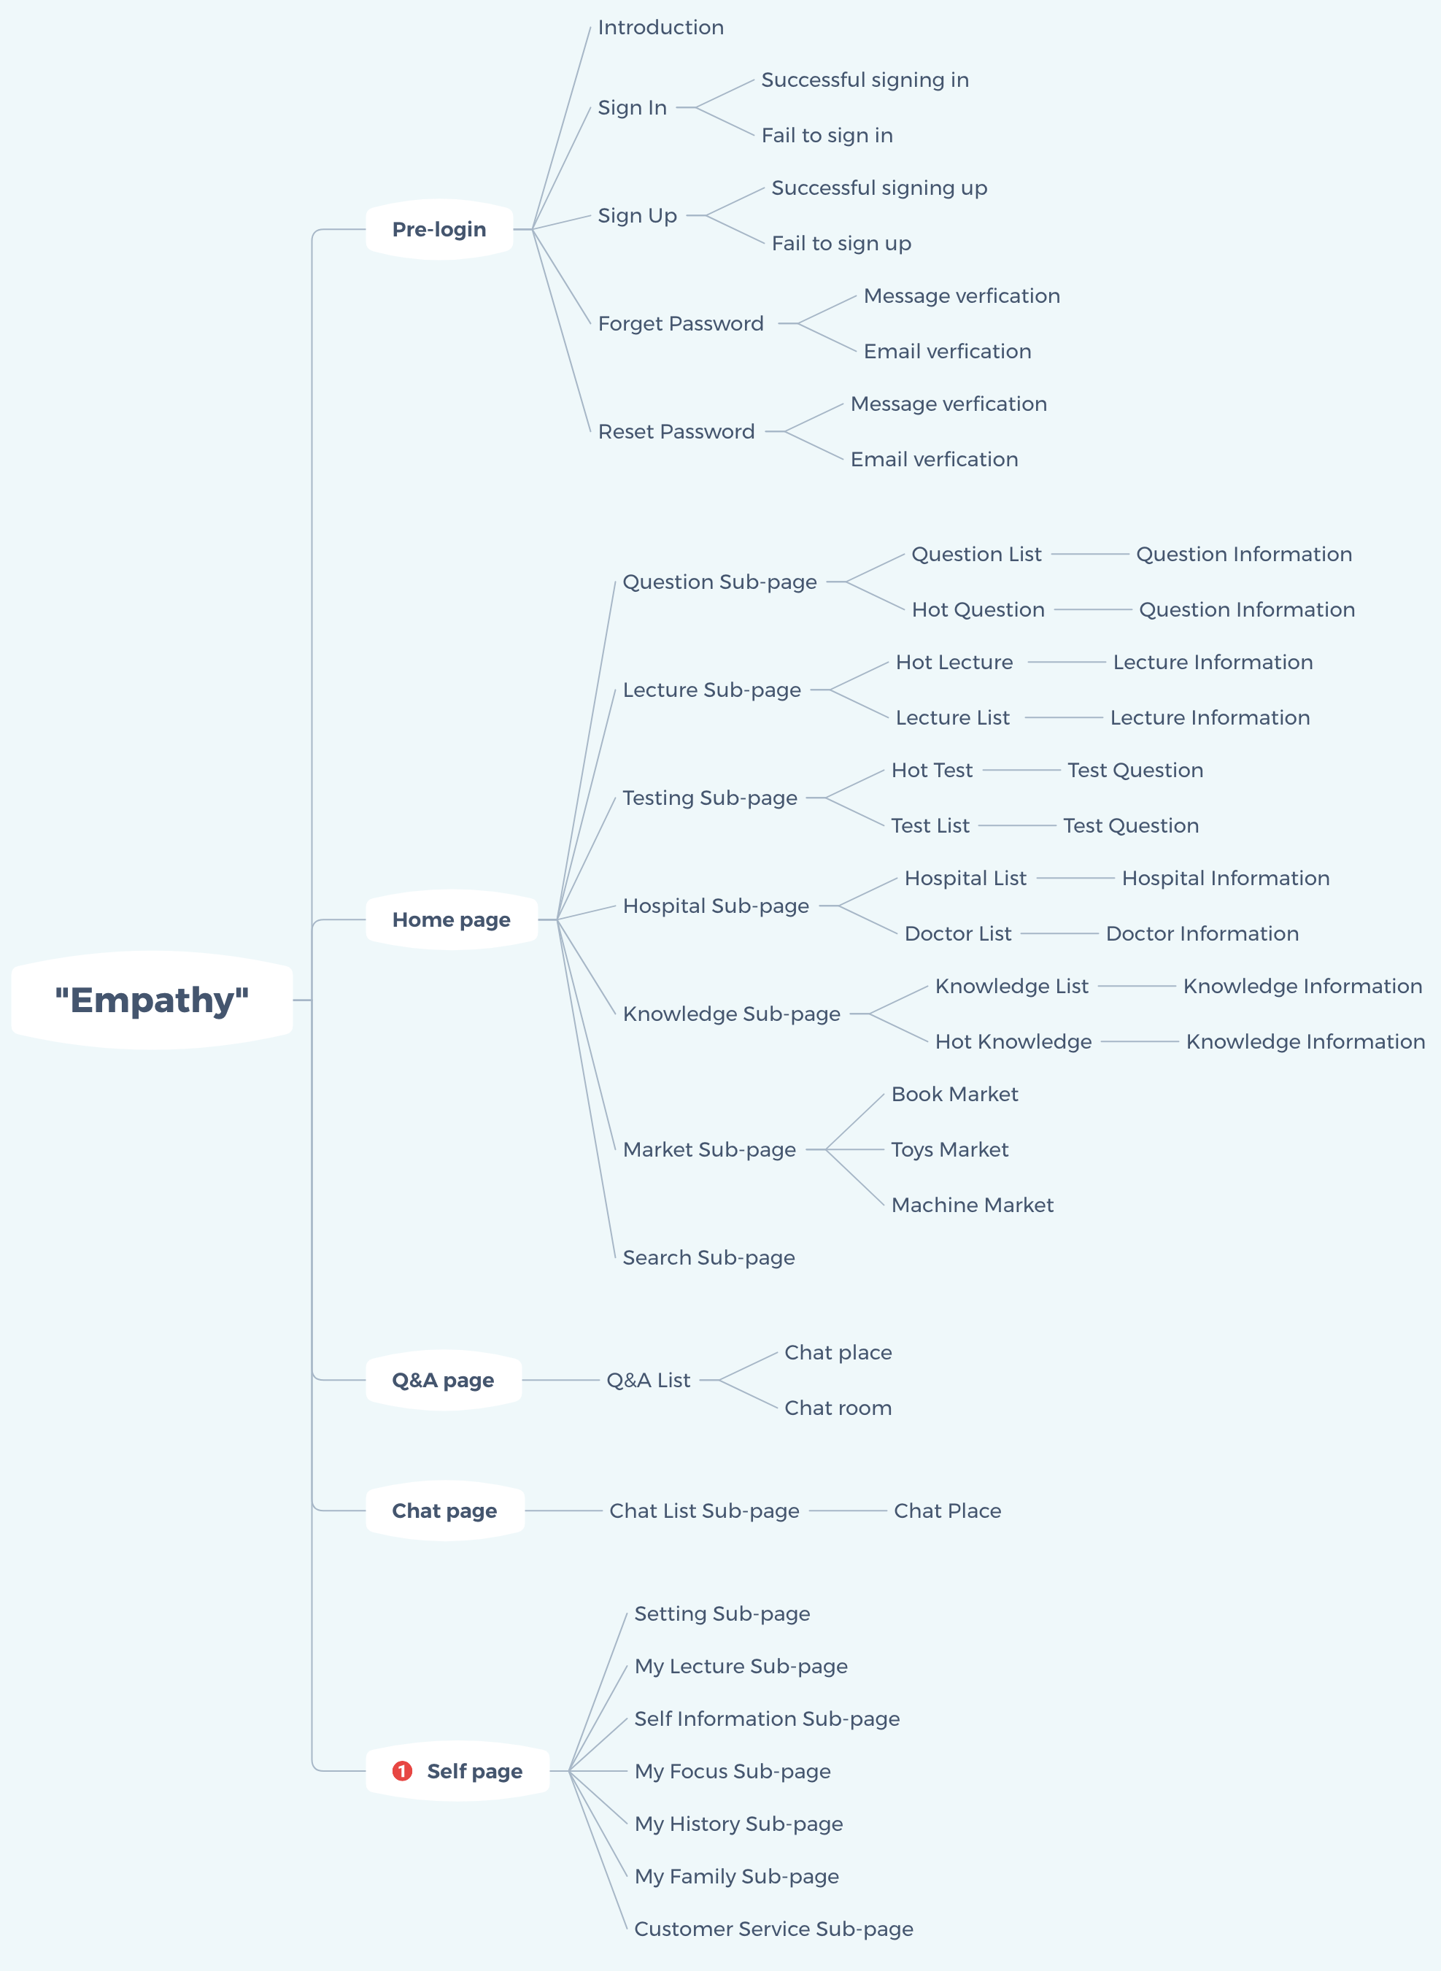

## Function Design

### Team distribution

|  |  |  |  |  |
| --- | --- | --- | --- | --- |
| Level 1 | Level 2 | Level 3 | Level 4 | Person in charge |
| Pre-login | Introduction |  |  | MING |
| Sign In | Successful signing in |  | MING |
| Fail to sign in |  | MING |
| Sign Up | Successful signing up |  | MING |
| Fail to sign up |  | MING |
| Forget Password | Message verification |  | MING |
|  | Email verification |  | MING |
| Reset Password | Message verification |  | MING |
|  | Email verification |  | MING |
| Home page | Question Sub-page | Question List | Question Information | SHAO |
| Hot Question | Question Information | SHAO |
| Lecture Sub-page | Hot Lecture | Lecture Information | YANG |
| Lecture List | Lecture Information | YANG |
| Testing Sub-page | Hot Test | Test Question | YANG |
| Test List | Test Question | YANG |
| Hospital Sub-page | Hospital List | Hospital Information | GAO |
| Doctor List | Doctor Information | GAO |
| Knowledge Sub-page | Knowledge List | Knowledge Information | YANG |
| Hot Knowledge | Knowledge Information | YANG |
| Market Sub-page | Book Market |  | XIN |
| Toys Market |  | XIN |
| Machine Market |  | XIN |
| Search Sub-page |  |  | MING |
| Q&A page | Q&A List | Chat place |  | SHAO |
| Chat room |  | SHAO |
| Chat page | Chatting List Sub-page | Chat Place |  | SHAO |
| Self-page | Setting Sub-page | | | TANG |
| My Lecture Sub-page | | | TANG |
| Self-Information Sub-page | | | TANG |
| My Focus Sub-page | | | TANG |
| My History Sub-page | | | TANG |
| My Family Sub-page | | | TANG |
| Customer Service Sub-page | | | TANG |

### Function Description

|  |  |
| --- | --- |
| Page | Description |
| 1. Pre-login | The purpose of this part is letting the users know the basic information of our system, or they can login or apply for a new account. |
| 1.1 Introduction | Introduce basic information of our application. |
| 1.2 Sign In | The users should correctly input their username or phone number or email address to sign in. |
| 1.2.1 Successful signing in | While the user’s successful login in, the application should notice the users that they have successfully login in. |
| 1.2.2 Fail to sign in | While the user’s unsuccessful login in, the application should notice the users that they may be get something wrong with the username or password. |
| 1.3 Sign Up | The user should apply for a new account if they don’t have one. |
| 1.3.1 Successful signing up | While the user’s successful sign up, the application should notice the user that his/her account has been active. |
| 1.3.2 Fail to sign up | While the user’s unsuccessful sign up, the application should notice the user that his/her account may be already signed up. |
| 1.4 Forget Password | While the user forgets their username or password, the user can use this function page to find back their account information and then they should reset their account password. |
| 1.4.1 Message verification | While the user is operating his/her account, they will be asked to input their phone number to verify to make sure the account security. (If they have.) |
| 1.4.2 Email verification | While the user is operating his/her account, they will be asked to input their phone number to verify to make sure the account security. (If they have.) |
| 1.5Reset Password | After the user’s verification, the application should allow the user to reset password, so that they can keep their account security. |
| 1.5.1 Message verification | Same as 1.4.1 |
| 1.5.2 Email verification | Same as 1.4.2 |
| 2. Home page | The most important page of this application. |
| 2.1 Question Sub-page | The user can use it to invite famous doctors to answer the question, and the users are also free to read the public discussion. |
| 2.1.1 Question List | The common question asked by the other uses lists. |
| 2.1.1.1 Question Information | The user can click the question they want to know, and read more about the question’s answers. |
| 2.1.2 Hot Question | This is all question list page. The user can ask questions in this page, the questions are free for all the user to see and discuss. |
| 2.1.2.1 Question Information | Same ad 2.1.1.1 |
| 2.2 Lecture Sub-page | The user can see can buy lecture to learn. |
| 2.2.1 Hot Lecture | Recommend the hot lectures |
| 2.2.1.1 Lecture Information | The concrete information of the lecture, the user can read it before they decide to buy the lectures. |
| 2.3 Testing Sub-page | The test subpage contains four pages of test recommendations, test details, test search results, and test pages. |
| 2.3.1 Hot Test | The test recommendation page has four sections, namely search bar, recommended test, index, and other tests. |
| 2.3.1.1 Test Question | The test page has three sections: questions, options, and a title bar. If necessary, there will be pictures |
| 2.3.2 Test List | The test list page consists of three parts: the search bar, the index, and the list. |
| 2.3.2.1 Test Question | The test list page consists of three parts: the search bar, the index, and the list. Jump to this page when the user chooses to view all tests, or search for a test, or find a test by index |
| 2.4 Hospital Sub-page | All hospital information is arranged according to the initials. Users can click on a hospital to enter the hospital information sub-page for consultation and viewing information. |
| 2.4.1 Hospital List | Display specific information about the hospital, such as address, contact information, reliability, etc., and provide the hospital's famous physician information outline and recommendations |
| 2.4.1.1 Hospital Information | Show a brief introduction of all doctors in a hospital and their star rating. Users can click on a doctor to view their information or initiate a consultation with them. |
| 2.4.2 Doctor List | Physician's details such as contact information, credit star rating, and good at subjects. |
| 2.4.2.1 Doctor Information | All hospital information is arranged according to the initials. Users can click on a hospital to enter the hospital information sub-page for consultation and viewing information. |
| 2.5 Knowledge Sub-page | The user can search the keyword that they want to read, or they can read the information recommended by the application. (hot knowledge) |
| 2.5.1 Knowledge List | The knowledge list of other users. |
| 2.5.1.1 Knowledge Information | The concrete information of one knowledge. |
| 2.5.2 Hot Knowledge | the hot recommended knowledge. |
| 2.5.2.1 Knowledge Information | Same as 2.5.1.1 |
| 2.6 Market Sub-page | The market shows some kinds of goods to customers, which is related to help children prevent psychological illness and mental disease. |
| 2.6.1 Book Market | Showing various kind of books which is helpful to children solve mental problem. |
| 2.6.2 Toys Market | Showing various kind of toys which is helpful to children solve mental problem. |
| 2.6.3 Machine Market | Showing various kind of medicine which is beneficial to children’s mental problem |
| 2.7 Search Sub-page | The user can search the information contenting the information that that what to have. |
| 3. Q&A page | Show doctor lists |
| 3.1 Q&A List | List all the doctor who provide service |
| 3.1.1 Chat place | The page will show if the reservation is successful. |
| 3.1.2 Chat room | Users can follow doctor or unfollow |
| 4. Chat page | It shows all content of chatting function |
| 4.1 Chat List Sub-page | Users can find four functions helping to communicate with doctor |
| 4.1.1 Chat Place | The keyboard will pop up by clicking input filed |
| 5. Self-page | The page is going to let the user manage their account via their favor. |
| 5.1 Setting Sub-page | The user can set some favor. |
| 5.2 My Lecture Sub-page | The user can see the lecture that they bought before. |
| 5.3 Self-Information Sub-page | The user can fulfill their self-information. |
| 5.4 My Focus Sub-page | The user can review what they like and keep before. |
| 5.5 My History Sub-page | The user can review the history knowledge that they read or see. |
| 5.6 My Family Sub-page | The user can add their family account, so they can keep track of their families. |
| 5.7 Customer Service Sub-page | The user can contact the customer service staff is necessary. |